DBMSL Mock Test

Aditya Sawant

31302

**Problem Statement:**

**7. Triggers:**

Consider a Employee database and write row-level triggers for the same. Implement both before & after triggers for the relevant database tables at the time of insertion, update and deletion. Implement using following schema:

**EMPLOYEE**(Emp_Id, First_Name, Last_Name, Email, Phone_No, Hire_Date, Job_Profile, Salary, HRA)

**COMPANY_INFO**(Emp_Count, Salary_Expenses)

**EMP_LOG**(Emp_Id, Old_Salary, New_Salary, Edit_Time, Job_Status)

* **Before insert:** Check the column value of FIRST_NAME, LAST_NAME, JOB_ID for following criteria:
* If there are any spaces before or after the FIRST_NAME, LAST_NAME, use TRIM() function to remove them.
* The value of the JOB_PROFILE will be converted to upper cases by UPPER() function.
* **After insert:** Every time an INSERT happens into EMPLOYEE table, insert relevant information into the EMP_LOG table. Also update the COMPANY_INFO table
* **Before update:** Each time the HRA is updated for the EMPLOYEE table, convert it into decimal value (i.e. for 10%, store 0.1)
* **After Update:** Each time the HRA is updated, accordingly update the salary in EMPLOYEE table & keep track of updated salary in EMP_LOG table.
* **Before Delete:** Every time a DELETE happens on EMPLOYEE table, accordingly change the JOB_STATUS in EMP_LOG table from ACTIVE to DELETED & keep track of EDIT_TIME
* **After Delete:** Keep the COMPANY_INFO table updated

**Queries:**

delimiter //

create trigger t1

before insert

on employee for each row

begin

set new.first_name = trim(new.first_name);

set new.last_name = trim(new.last_name);

set new.job_profile = upper(new.job_profile);

end;

//

delimiter //

create trigger t2

after insert

on employee for each row

begin

declare emp_cnt integer;

declare sal_exp integer;

declare ifempty integer;

select count(emp_count) into ifempty from company_info;

if ifempty != 0 then

select emp_count, salary_expenses into emp_cnt, sal_exp from company_info where emp_count = ifempty;

insert into company_info values(emp_cnt+1, sal_exp+new.salary);

else

insert into company_info values(1, new.salary);

end if;

insert into emp_log values(new.emp_id, 0, new.salary, current_time(), 'Active');

end;

//

delimiter //

create trigger t3

before update

on employee for each row

begin

declare hhra integer;

if old.hra > 1 then

set new.hra = new.hra/100;

elseif new.hra > 1 then

set new.hra = new.hra/100;

end if;

end;

//

delimiter //

create trigger t4

after update

on employee for each row

begin

if old.hra != new.hra then

insert into emp_log values(new.emp_id, old.salary, (old.salary*new.hra)+old.salary, current_time(), 'Active');

end if;

end;

//

delimiter //

create trigger t5

before delete

on employee for each row

begin

insert into emp_log values(old.emp_id, old.salary, old.salary, current_time(), 'Deleted');

end;

//

delimiter //

create trigger t6

after delete

on employee for each row

begin

declare emp_cnt integer;

declare sal_exp integer;

declare maxcount integer;

select count(emp_count) into maxcount from company_info;

if ifempty != 0 then

select emp_count, salary_expenses into emp_cnt, sal_exp from company_info where emp_count = maxcount;

insert into company_info values(emp_cnt-1, sal_exp-old.salary);

end if;

end;

//

**Output:**

Insert triggers:

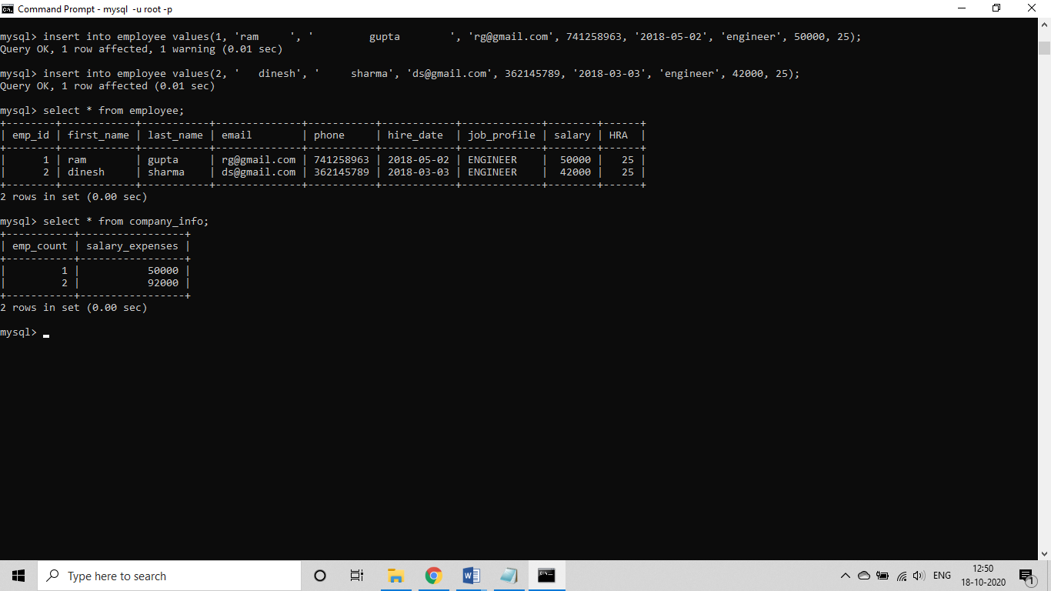

Update triggers: 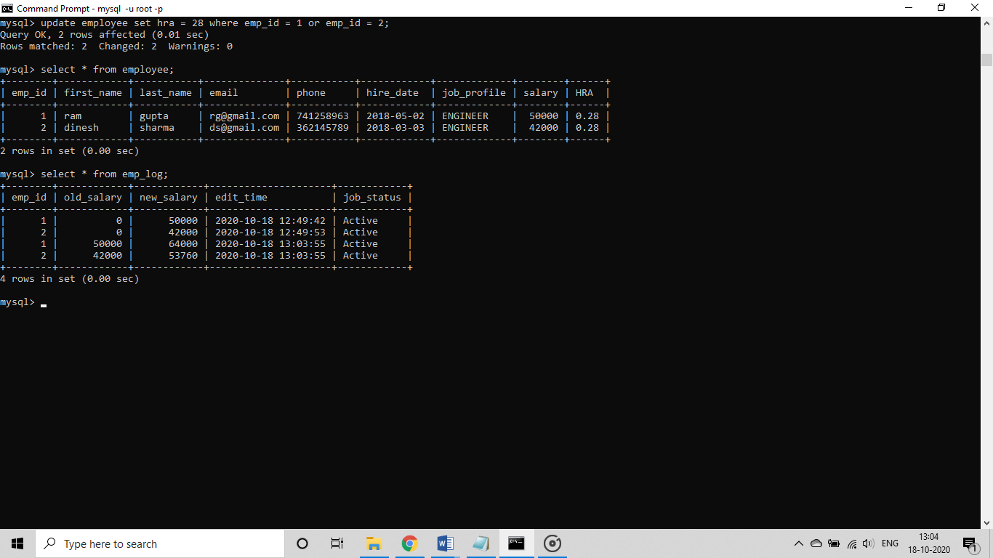

Delete triggers:

